Client and Property | Mrs Robina Hattersley,  3, Mill Race  Fisherton  Salisbury  SP2 7RX.
Prepared By | Peter Wynn
Camera: | Fluke TiR 1 serial no: 12040181
Date & Time | The survey was carried out on 11th April 2013 between 8pm and 9.40pm. (NB camera times are GMT)
Weather | The external temperature was quite mild at about 10 degrees centigrade externally. The house had been heated to about 22 degrees, giving an adequate differential. There had been recent rain but it was dry at the time of the survey.
Description of Building | The building dates from the early 18th Century, and is of single skin brick construction with a tile roof. Almost all the windows are double glazed or have secondary glazing. There is gas central heating. Accommodation is on three levels with two bedrooms in the roof space.
Objectives | The objective of the report was to take thermal images of key areas of the building in order to identify any thermal anomalies that might indicate potential energy saving measures.
Note on reading the temperatures | The colours are relative to the highest and lowest temperature in any particular image – please make reference to the scale on the right if trying to assess the temperature from the colour. The larger font number in the middle of the scale indicates the temperature at the centre of the screen. Temperatures are in degrees centigrade.
Disclaimer | This report is produced for the interest of the householder and contains no recommendations for action. Should the householder wish to undertake remedial work as a result of the observations they should establish the correct course of action for themselves, with appropriate professional advice.

1. Entrance to Property
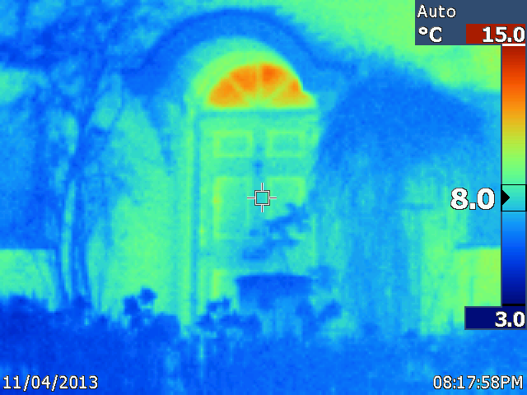
Observation | Comment
The fan light (window over the door) appears to be warmer than the rest of the door.  The edges of the door panels appear to be warm – see note to Image 4 below. | This is a single glazed window, so it will be losing some heat. Additionally, it is transmitting radiant heat from surfaces inside the building, which make it appear warmer.

2. South Elevation of Property
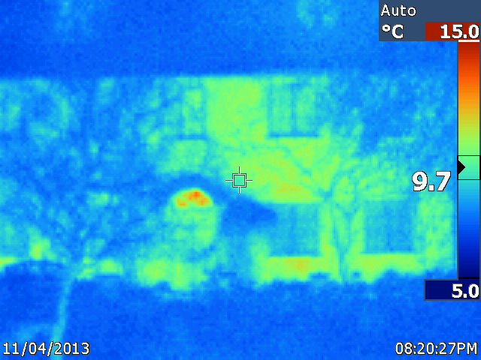
Observation | Comment
The fan light appears warm | See note to image 1 above

3. South Elevation – ground floor windows
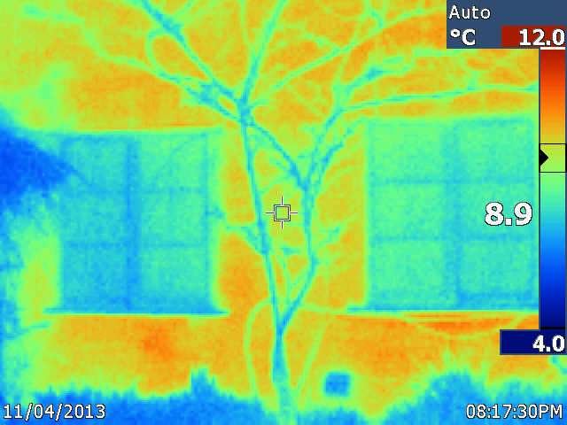
Observation | Comment
The wall-trained plant appears cool, as do the window frames.  The wall is warmer than the windows and has quite patchy heat distribution. | The plants appear cool because they are losing heat by radiation even though the air temperature is slightly higher at about 10 degrees.  These windows have secondary glazing which appears to be very effective. However, these are reflective surfaces and may be reflecting radiation that corresponds to low temperatures outside the building.  It is hard to state how effective walls are at retaining heat but the patchiness is an indicator that these single skinned walls are losing quite a lot of heat.

4. Front door - inside
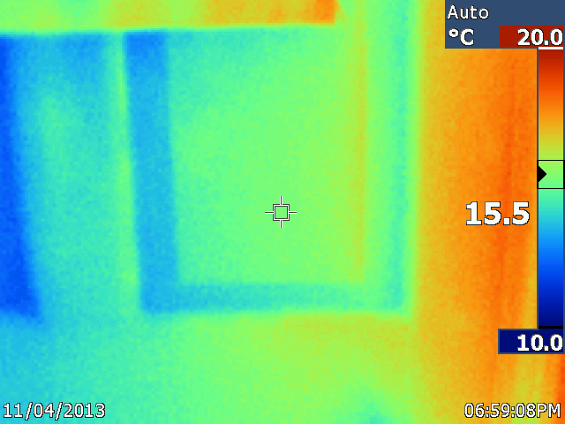
Observation | Comment
The edges of the panels are cool  The right side of the door is warm | This is a traditionally constructed door and the panels are loose-fitted into the frame. Where they fit they are tapered quite thinly and heat is being lost in these areas.  This is due to the radiator, which is quite close.

5. Front Door - inside
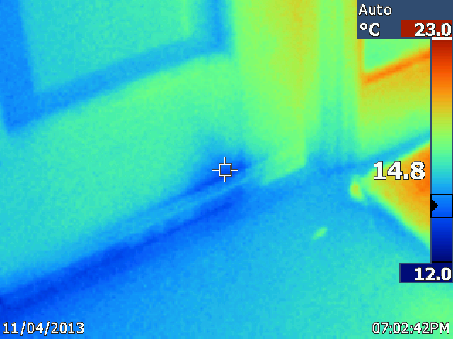
Observation | Comment
The bottom of the door is cool and there is a patch of cool on the door rail (dead centre of image) | This patch of cold surface does not seem to relate to a draught and hence may be a sign of damp wood in the rail. (A rail is a horizontal member of the door)

6. Entrance Hall - radiator
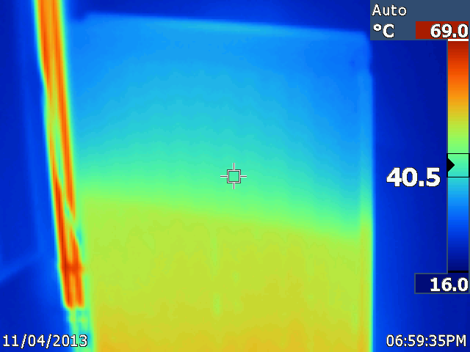
Observation | Comment
The top of the radiator is cool. | The radiator needs bleeding, as it has air trapped in it. – See also image 7 below.

7. Entrance hall - radiator
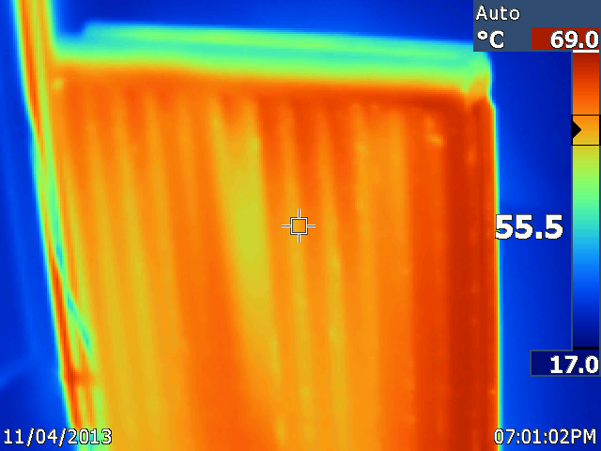
Observation | Comment
The radiator is now warm! | While the owner bled the radiator, the heat could be seen to rise up. As is shown here, the heat was not uniform and some patches remained cool for a few minutes before the temperature evened out. One possibility is that this radiator may have some rust trapped in it which is restricting the flow.

8. Ground floor- studio
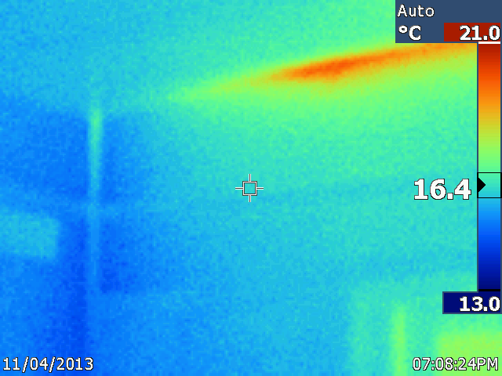
Observation | Comment
A heat anomaly is visible above the entrance to the studio. | It was not possible to identify the source of this patch of heat – it is probably due to a central heating pipe above.

9. First landing – South side
The bedrooms are on the third floor, built into the roof. One each side of these rooms is a low wall (a purlin wall) and behind this is a triangular-sectioned space which has no use and may have no access.
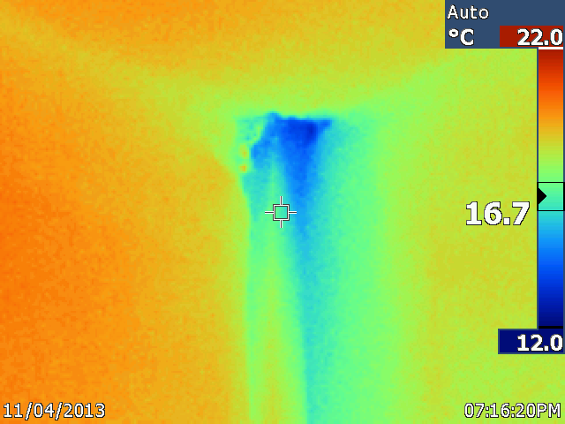
Observation | Comment
An area of cold is observed | This image shows a gap in the ceiling above the first landing which leads directly into this space. The streak of blue is caused by cold air continuously sinking out of the unheated space .

10. Bedroom 2 – West side

Because of the shape and size of bedroom 1 it was hard to get meaningful images with the Thermal Imaging Camera. However, the type of anomaly seen in this image was not observed in bedroom 1, hence it is to be supposed that the insulation between the rafters is more effective there.
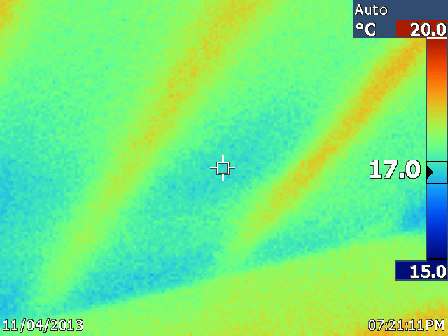
Observation | Comment
The rafters are visible through the plasterboard as warm heat anomalies | The owner commented that bedroom 2 is warmer than bedroom 1 even though the construction heating and size are about the same. See “further observations” below for a possible explanation. This image shows that the insulation between the rafters is not as effective as the rafter itself. The insulation was not observed at any point.

11. Bedroom 2
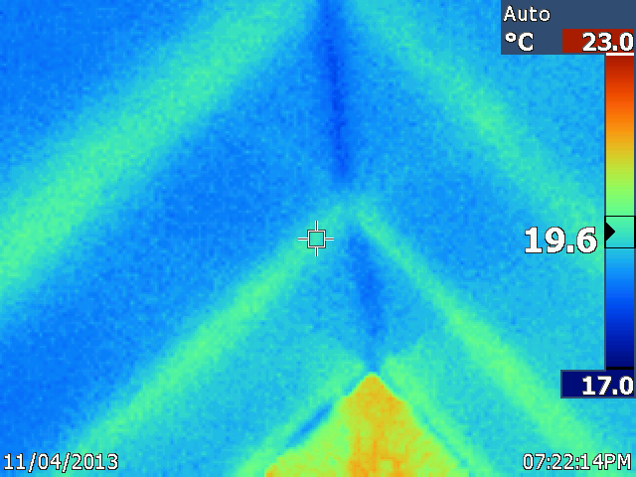
Observation | Comment
As per image 10 the rafters can be seen. In addition, a line of colder surface is seen along the ridge | The cold ridgeline suggests that the join of the plasterboard is not very well sealed and/or there is very little insulation above it.

12. Bedroom 2 – floor adjacent to dressing table
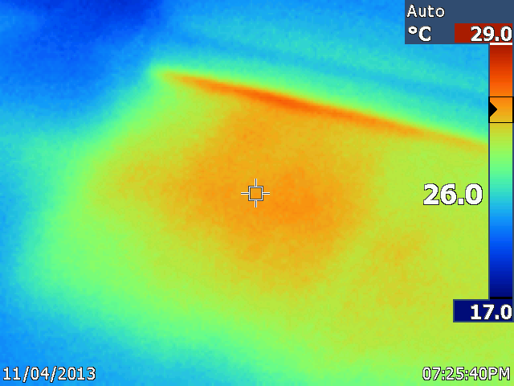
Observation | Comment
A rectangular are of floor is very warm | This equates to either the airing cupboard or the run of the hot water pipes from the boiler to the airing cupboard.

13. Airing cupboard. Magnetic particle remover for central heating pipes (?)
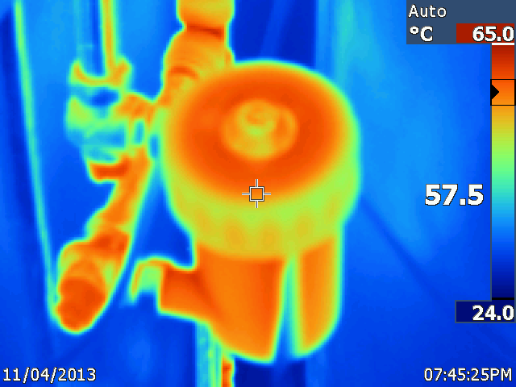
Observation | Comment
All the surfaces in the airing cupboard are very warm | This picture has been included to illustrate how hot all the surfaces are in the airing cupboard.

14. Bathroom window
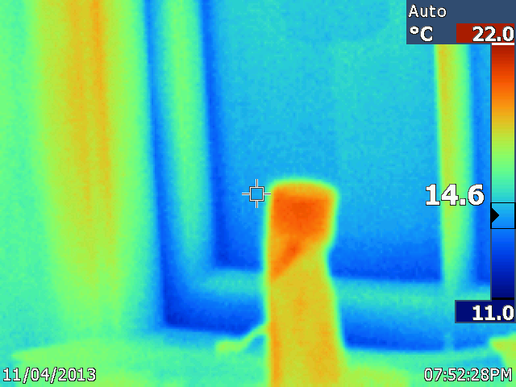
Observation | Comment
Cool surfaces at the base of the window which is slightly ajar | The window has to be opened occasionally to control moisture after the bathroom has been used. This image illustrates cold air coming in through quite a small gap.

15. Kitchen – south east corner
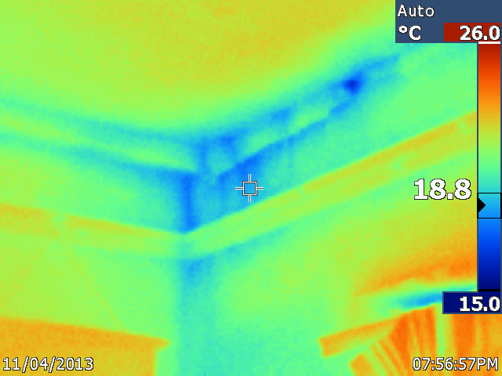
Observation | Comment
Area of cold surfaces | As per image 9 above, there appears to be a crack here that is letting in cold air from the space behind the purlin wall above it

16. Living room – ceiling adjacent south wall
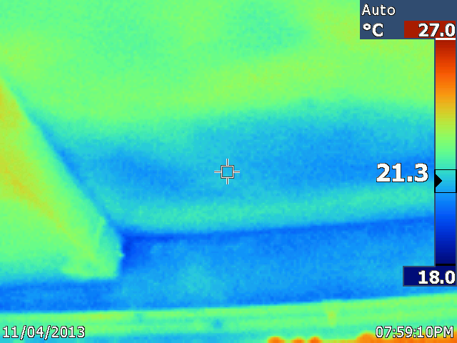
Observation | Comment
A well defined patch of cold surface is visible | This probably equates to the space behind the purlin wall, which lies immediately above the margin of the living room. The beam to the left had a significant area of cracked plaster.

17. Living room – east wall
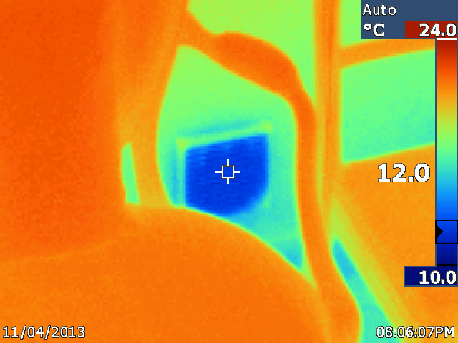
Observation | Comment
A cold anomaly was observed in the lower part of the east wall | The owner advised that this vent was installed at the insistence of the gas company that installed a coal-effect gas fire in a period fire-place. The vent was the source of a very significant draught into the room, of air at only slightly above the external temperature.

18. South Elevation of Property
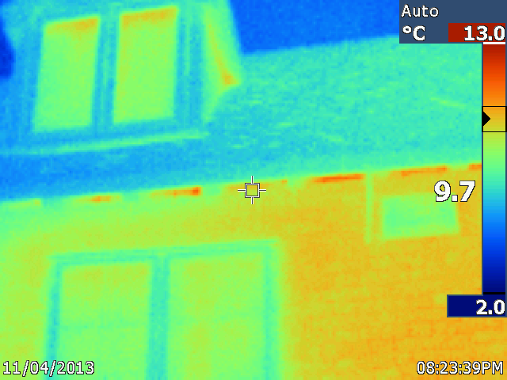
Observation | Comment
Small patches of warmth are observed within the eaves | Traditional building construction usually has a gap for ventilation at this point and hence some heat will escape from here.

19. North Elevation of Property
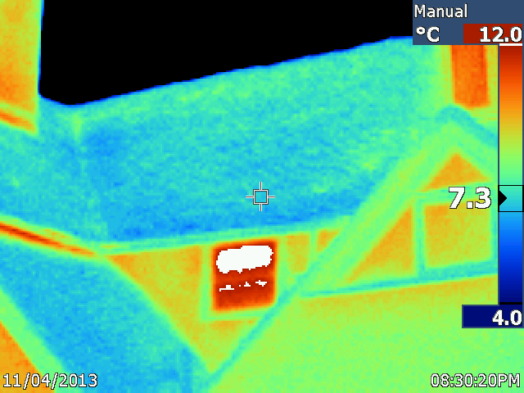
Observation | Comment
The window in the centre of the image appears warm. | This is (?) the window onto the half-way landing and it is not double glazed.
Further observations

Where gaps between heated and unheated spaces are identified it may be helpful to block them up to reduce draughts and heating costs. Builders’ foam can be an effective way of doing this.

Bedroom 2 is apparently cooler that bedroom 1. This may possibly be due to the fact that the cold water header tank is located in Bedroom 2. This will continually absorb heat from the room, reducing its temperature. It might be possible to reduce this effect by insulating the tank.

As a general rule it is worthwhile insulating any pipes that carry hot water. The exception is heating pipes where they run through occupied spaces. In particular it is usually worthwhile insulating (lagging) all the pipes in the airing cupboard.

