Client and Property | Angela Bywater  127, Rampart Road  Salisbury  SP1 1JA
Prepared By | Peter Wynn
Camera: | Fluke TiR 1 serial no: 12040181
Date & Time | Wednesday 13th March 2013, between 2030 and 2300hrs
Weather | The external temperature was quite cold at about -3 degrees centigrade externally. The house had been heated to about 20 degrees, giving an adequate differential.
Description of Building | The building reportedly dates from the 1860. It is rendered so the brickwork cannot be seen. An adjacent building in the same terrace is not rendered and the brickwork is Flemish Bond. However, the householder stated that it is cavity walled and indeed a cavity can be seen around the front door where it has been opened up.  Almost all of the windows have been updated to double-glaze.  The living space has been built into the roof.  The house is aligned approximately north-south and hence it faces west onto Rampart Road.  Natural gas is supplied, and a wood burner supplements the heating.
Objectives | The objective of the report was to take thermal images of key areas of the building in order to identify any thermal anomalies that might indicate potential energy saving measures.
Disclaimer | This report is produced for the interest of the householder and contains no recommendations for action. Should the householder wish to take remedial work as a result of the observations they should establish the correct course of action for themselves, with appropriate professional advice.

1. Entrance to Property
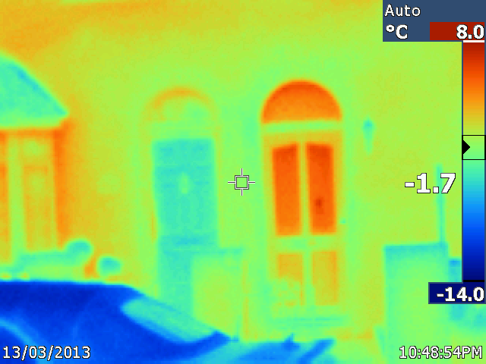
Observation | Comment
The neighbour’s door (on the left) is significantly cooler than the door to No 127! | The householder reported that the neighbour has a relatively new door and that they have installed an internal porch, which improves the sealing and isolated the heated part of the house.

2. West (frontal) Elevation of Property
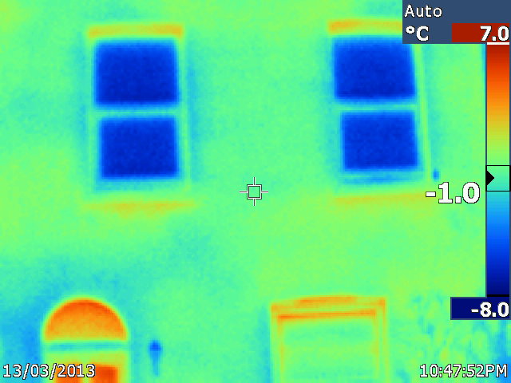
Observation | Comment
The upper windows look cool.  The lower window is quite warm in its upper parts | They are reflecting low temperature radiation from the sky  It appears that heat is being lost from the infill member above the head jamb. This may be made from wood with no insulation.

3. Front door from inside
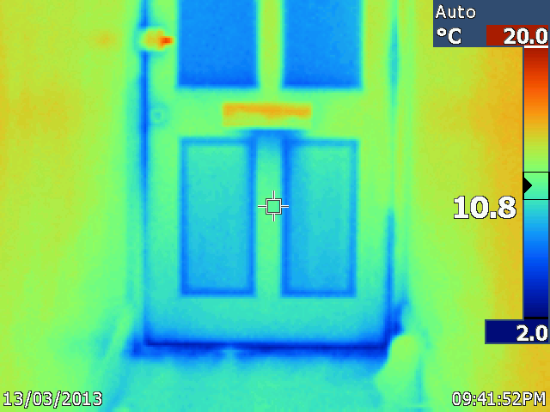
Observation | Comment
Some cool patches are observed mainly around the bottom of the door. | The householder is aware of problems here.

4. Inside of front door
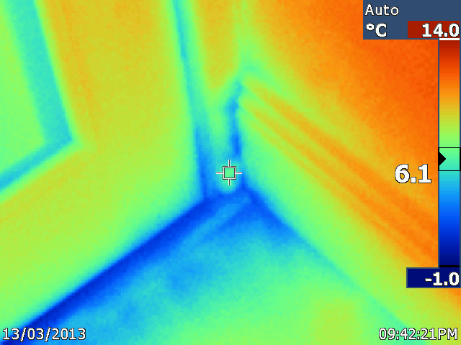
Observation | Comment
Cool patches to lower part of door | The householder thinks that there may be damp coming in here.

5. Outside of front door – hinge side lower corner
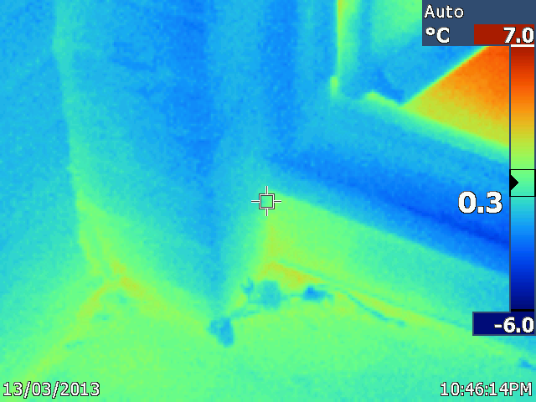
Observation | Comment
Slight warmth showing low down. | This may be damp conducting heat out of the house. The householder has had to replace the lower part of the door jamb because of rot.

6. Smoke detector
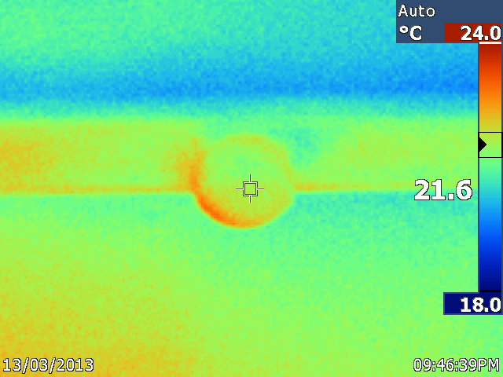
Observation | Comment
The smoke detector is affixed to a ceiling joist (?) in the entrance lobby. It appears to be warm. | The smoke detector is probably in the path of warm air moving from the adjacent living room and hence is slightly warm.

7. “Coal window”
This is a long narrow window, which may have had a function in the past to receive coal deliveries.

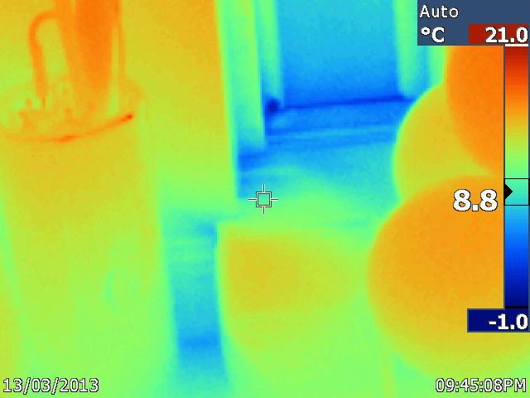
Observation | Comment
This window is below the first flight of stairs and is quite cold. | The window is single glazed. The householder also noted some damp in this area.

8. Below the coal window
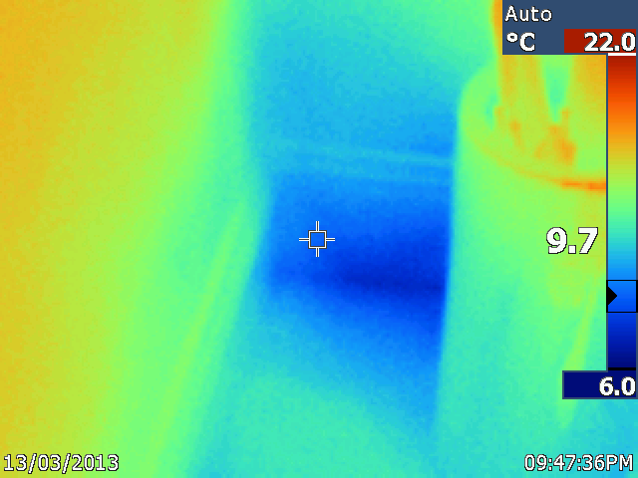
Observation | Comment
Having moved some items, the cold area was exposed.

9. Walls to first landing
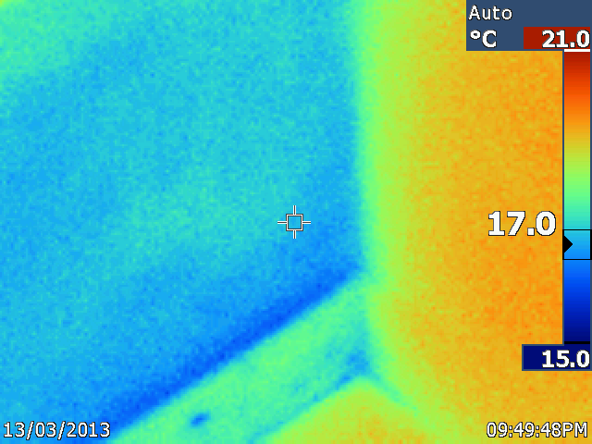
Observation | Comment
Considerable difference in temperature is noted between the left hand wall, which is external, and the right hand, which is internal. | The householder is aware that this part of the external wall may not be cavity-filled. Compare to image 14 which shows the same part of the wall from outside.

10. First Bedroom - ceiling
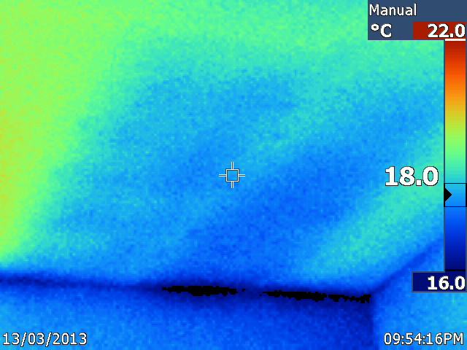
Observation | Comment
Cold patches are noted on the ceiling | This indicates missing areas of insulation.  Above the ceiling is a loft space accessible from the bathroom, and the householder is aware of unsatisfactory insulation in this space.

11. First bedroom - wardrobe
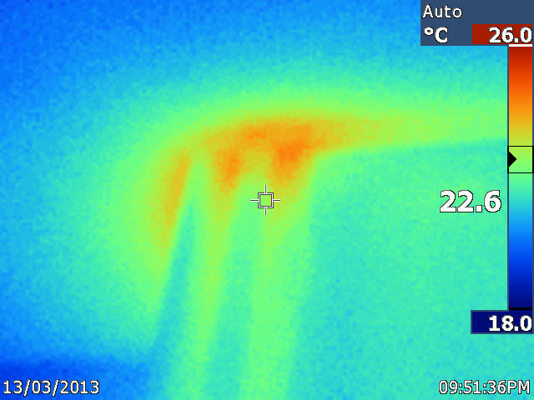
Observation | Comment
Elevated temperature around the top of a wardrobe. | On further inspection, a concealed part of the wardrobe side was found to contain hot water pipes.

12. Bedroom 2 – roof space behind purlin wall
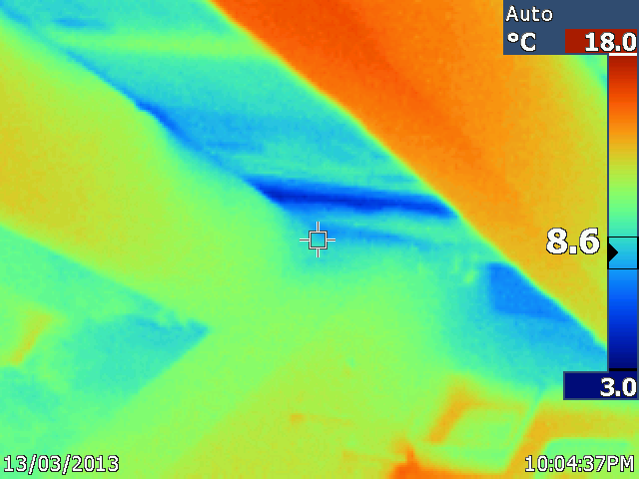
Observation | Comment
Cold patches are visible.  Warm patches are visible | This part of the roof space abuts the leaded gutter at the base of the roof.  The cold patch seen as an irregular blue patch on the upper surface of the rafter on the left is suspect. This could be cold air moving in through the tiles, or it could be a patch of damp.  Some insulation has been removed, allowing heat to move upwards from bedroom 3 below.

13. External roof tiles

These tiles are immediately above the roof space shown in image 12 above.

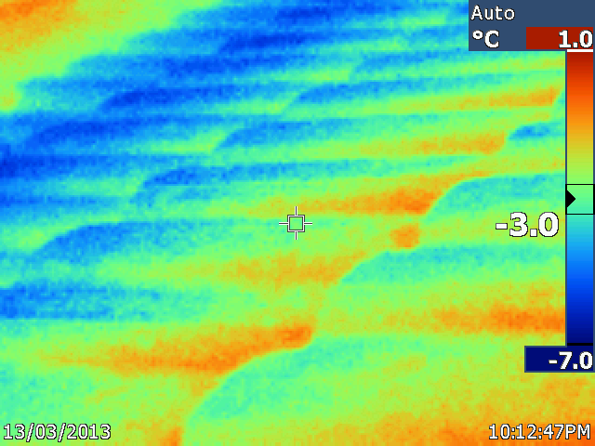
Observation | Comment
Warmer patches are seen at the top edge of the tiles | Some heat loss is occurring here.

14. Back wall

The blue panes belong to the greenhouse, which is obscuring the kitchen which is in a single storey extension.

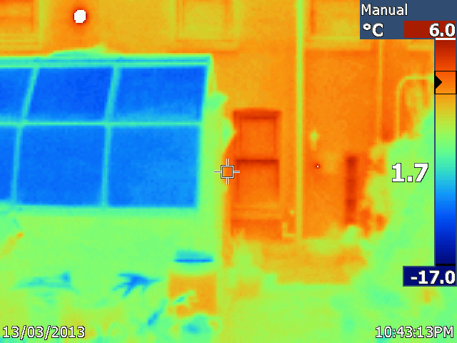
Observation | Comment
Hot spot on the wall of the neighbour’s property  The “coal window” is visible just to the left of the figure 1.7 and shows quite warm.  The wall to the left of the drainpipe is warmer that the wall to the right of it. This contras  t was more apparent in the field. | This is their gas flue  Compare with image 7 above.  Compare with image 9 above.

15. Roof to rear of property
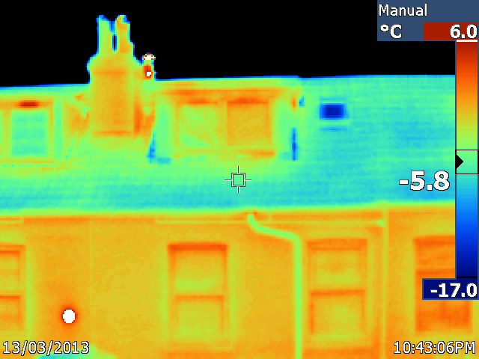
Observation | Comment
Some heat loss is visible from the trickle vents in the dormer windows.  The skylight above the stairs is showing very cold.  The right hand chimney is hot | This is reflecting the very low temperature radiation from the sky.  This chimney is in use.

Further observations

The householder has taken considerable effort to reduce damp and to insulate the house, and this is paying off.

The camera was useful in identifying the routes of some hot water pipes.

