Client and Property | Sarah Kurslake and Julie Dunford  17 Wishford Road  Wilton  SP2 0JG
Prepared By | Peter Wynn
Camera: | Fluke TiR 1 serial no: 12040181
Date & Time | The survey was conducted between 8pm and 10pm on Friday 8th March 2013.
Weather | The external temperature was quite mild at about 9 degrees centigrade externally. The house had been heated to well over 20 degrees, giving an adequate differential. There was slight rain.
Description of Building | The house was built in the 1930s and is one of a row of semi detached/terraced houses. Construction is reportedly modular concrete, pebbledashed.
Objectives | The objective of the report was to take thermal images of key areas of the building in order to identify any thermal anomalies that might indicate potential energy saving measures. In addition the occupiers can use it to verify the effectiveness of their own energy saving measures.
Disclaimer | This report is produced for the interest of the householder and contains no recommendations for action. Should the householder wish to take remedial work as a result of the observations they should establish the correct course of action for themselves, with appropriate professional advice.

1. Front aspect of property (West facing)
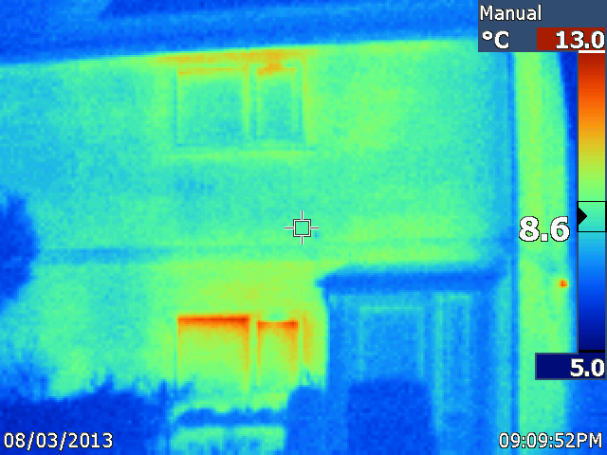
Observation | Comment
The image shows the front porch door of the property.  The porch is cooler than the surrounding walls shower than the adjacent walls. | The porch appears to be performing effectively in retaining the heat from the house
The windows are losing some heat. | Given the significant temperature differential this is probably acceptable. The main heat source is in the living room which is in the room behind the ground floor window.
There is some variation in the surface temperature of the wall. | It is not know whether this may be due to varying amounts of cavity wall insulation

2. Front Porch – new insulation being installed
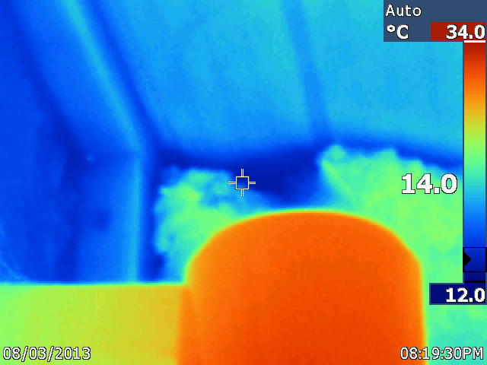
Observation | Comment
There are cool patches around the edges of the insulation | It is worthwhile ensuring that the insulation goes right to the edges of the cavity that it is filling as this stops any air from circulating , while reducing its effectiveness.

3. Inside – Hot water pipes in the kitchen
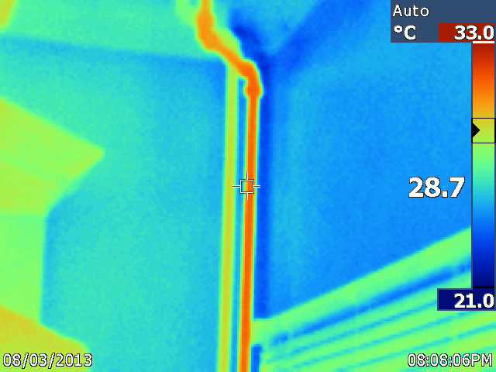
Observation | Comment
Hot and cold water pipes adjacent to each other. | Probably flow and return from radiator feed which have just stopped actively heating.

4. Living room – wood stove
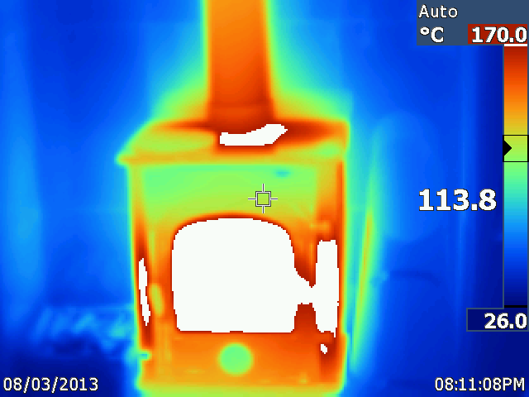
Observation | Comment
A very effective woodstove!

5. Living room
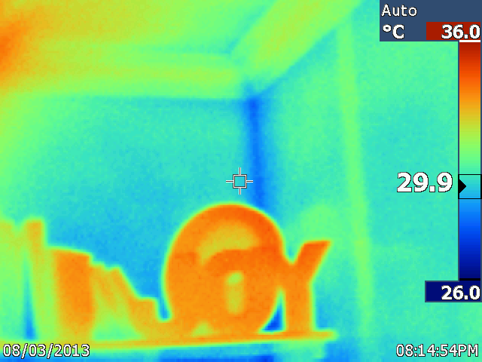
Observation | Comment
Hot spot on the left hand side | This is the heat from the chimney coming through the wall
Warm strip on the right hand side | Probably a plaster with different thermal properties has been used to fill the channel cut for an electrical cable.

6. Bedroom - front
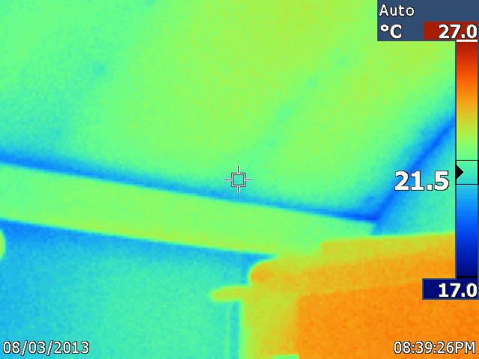
Observation | Comment
Cool patch to the right hand side | The owner commented that this area had attracted damp in the past. This is a shared wall, and there is no apparent reason why is should be damp.  The rafters can be seen as coolspots on the sloping ceiling.

7. Bedroom - back
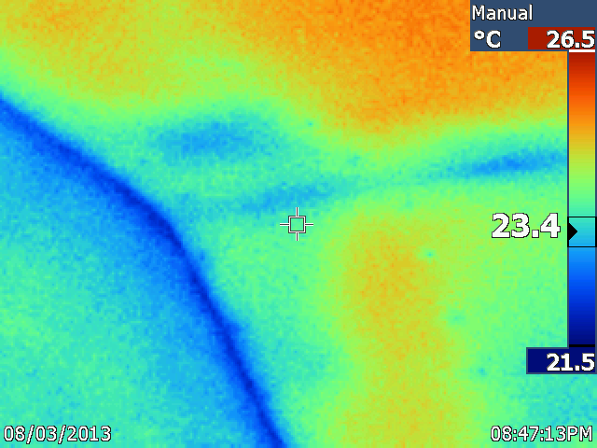
Observation | Comment
Cool patches are seen on the sloping ceiling. | Patches of insulation are missing. The owner explained tat the insulation had been removed to improve air circulation in the attic, which had become quite damp.

8. Back bedroom window/fire escape
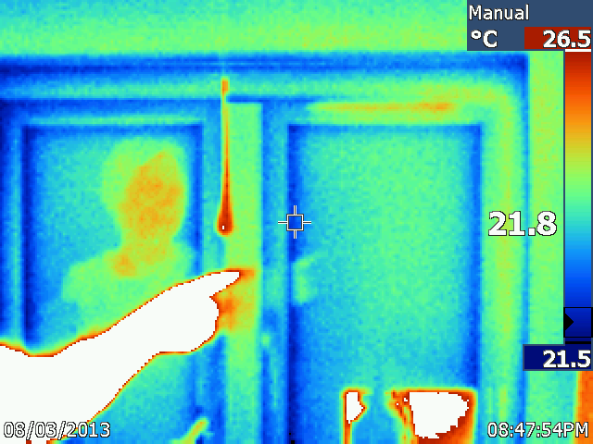
Observation | Comment
Significant cool areas at the join of the window frame. | The owner commented that it was possible sometimes to feel a draught from this window even though it is comparatively new.  Compare this to the external image below (Figure 10).  Note that the seal may be improved by lubricating the hinges. Owner to seek advice from the installer.

9. External view of back bedroom window
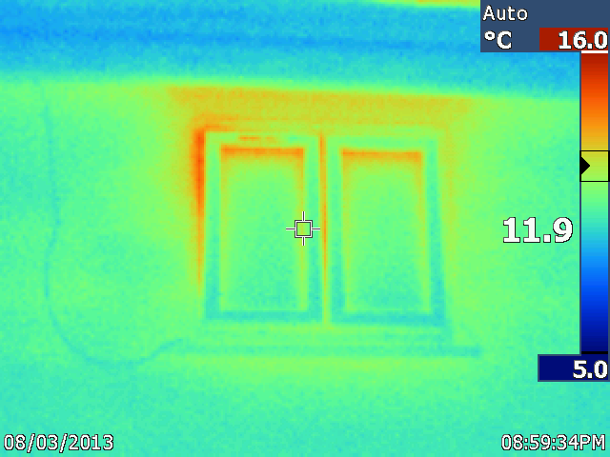
Observation | Comment
Significant heat loss to the left hand side of the window. | The asymmetry of the heat loss suggest that it could be due to ill-fitting frames within its casing.

10. Loft
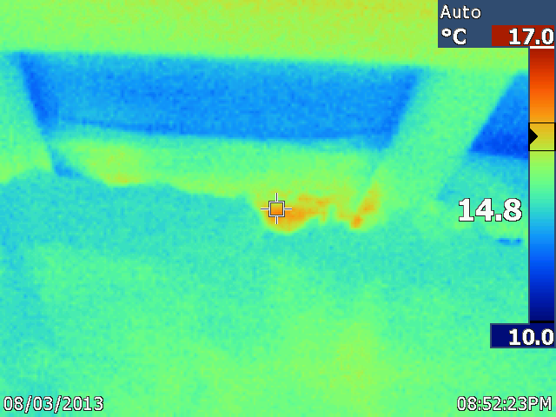
Observation |  | Comment
No significant anomalies were observed in the loft space apart from the one shown above | This corresponds to the location where the owner had removed some insulation to improve the circulation

11. External – bathroom window
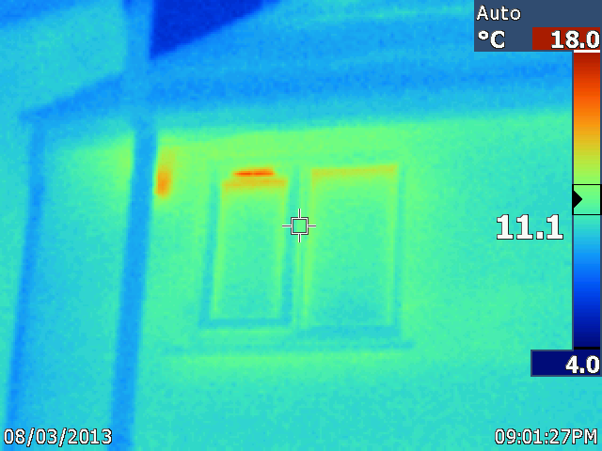
Observation |  | Comment
An anomaly is seen above the window | This is the trickle vent in the window.
A further anomaly is seen behind the vent pipe to the left of the window. | This is the bathroom extractor, which is not on, but is vent some heat nevertheless.

12. Kitchen window
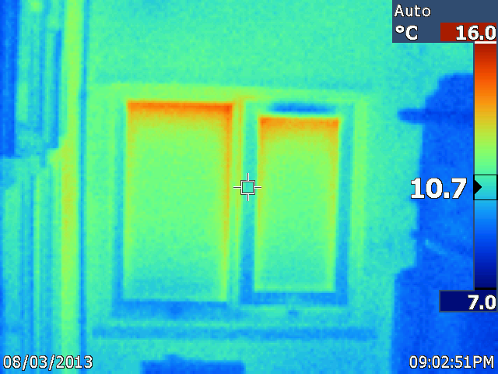
Observation |  | Comment
A cold anomaly is seen just above the right hand pane | This is probably the trickle vent. The house was very warm, and the upward movement of hot air in the house is drawing cold air in through the vent.

13. Rear of property
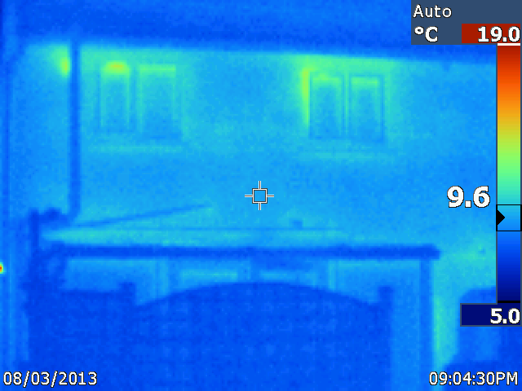
Observation |  | Comment
Compare Figure 1 – this wall is almost a degree warmer. | It is possible that the cavity wall insulation was installed less effectively on the front of the building. It might be expected that the front wall would be warmer having had the benefit of the evening sun.

14. Front of property - roof
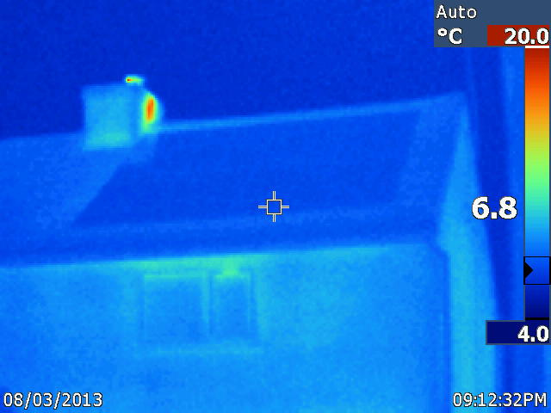
Observation |  | Comment
Thermal anomaly seen on the chimney | The wood stove is in operation

Further observations
The occupants have spent considerable time improving the energy efficiency of their home.

We attempted to illustrate the difference between he insulated external wall and an internal wall but this was not possible to show on an image because of the restricted angle of view of the camera.

