Client and Property | Wilton Community Centre  West Street  Wilton  Salisbury  Wiltshire  SP2 0DG
Prepared By | Peter Wynn
Camera: | Fluke TiR 1 serial no: 12040181
Date & Time | The survey was carried out in the evening of Tuesday 26th March 2013 between 7pm and about 8:45 pm
Weather | The external temperature was about 0 degrees centigrade externally. The interior had been heated to around 20 degrees, giving an adequate differential.
Description of Building | This is a late Victorian building predominantly of brick although the frontage contains a mix of ashlar blocks and flint in the local vernacular style. There is a slate pitched roof, the interior and hence construction of which was not seen. Much of the interior has a false suspended ceiling which was added to reduce heating costs. This and the break-up of the building into different rooms has led to a number of windows being redundant or in part use. The older part of the building is probably single skinned, but some newer extensions are double skinned brick. The larger windows are all double glazed.  A solar photovoltaic array has been installed on the roof.  Heating is by gas boiler.
Objectives | The objective of the report was to take thermal images of key areas of the building in order to identify any thermal anomalies that might indicate potential energy saving measures.
Disclaimer | This report is produced for the interest of the building’s management and contains no recommendations for action. Should the managers wish to take remedial work as a result of the observations they should establish the correct course of action for themselves, with appropriate professional advice.

1. Entrance to Property
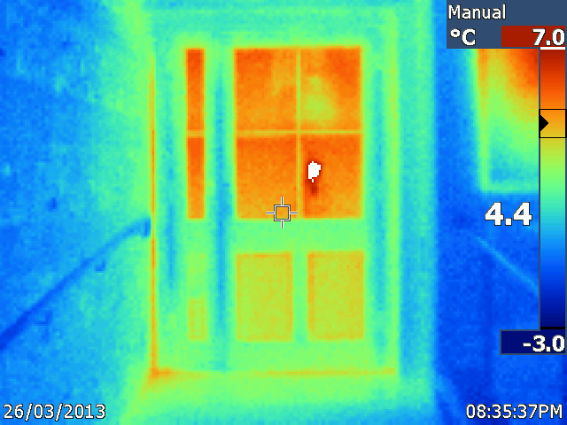
Observation | Comment
Thermal anomaly seen to left hand side of door against the wall.  The door itself is clearly quite warm | This was not noted in the field and suggests some heat loss where the frame of the door and side-light abut.  The door itself is of ordinary wooden construction and may not be very effective at retaining heat.

2. Front Door from inside – top edge
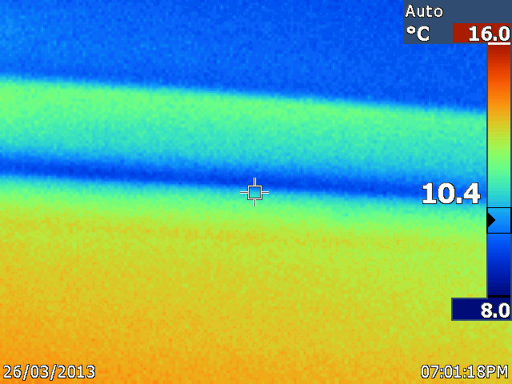
Observation | Comment
A cold surface is seen between the door and the jam. | Heat is being lost in this area.

3. South East corner of Room 1
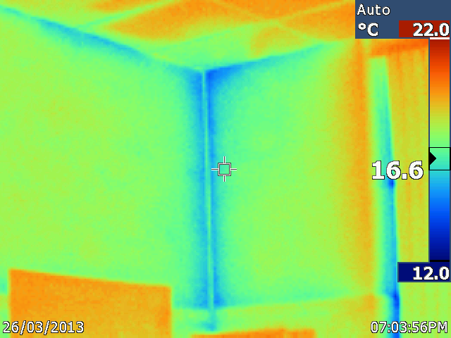
Observation | Comment
Cold patches are seen in the corner and next to the ceiling | The false ceiling partially isolates the room from the roof space. However, it is not sealed and hence cold air can seep through from above.

4. West end of Room 1
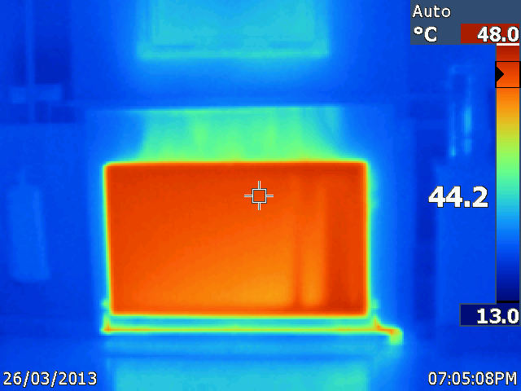
Observation | Comment
The effect of warm air rising from the radiator is seen. | Note that the small protrusion of the wainscot effectively stops the warm air from heating the wall above it.

5. South wall of Room 1
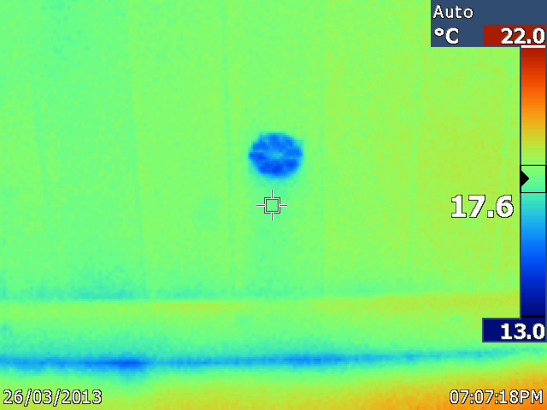
Observation | Comment
Cold air coming in through a vent in the wainscot | The air behind the wainscot is unheated and hence seeps in where the wainscot is unsealed against the floor. Overall, the wainscot probably contributes to the thermal efficiency of the building even if it leaks.

6. Hot water pipe Room 2
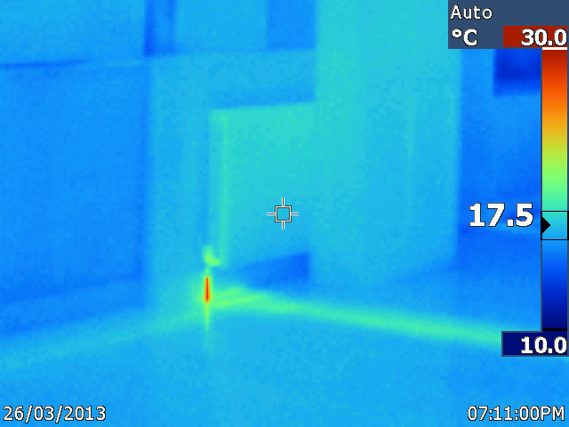
Observation | Comment
Hot pipes can be seen running towards the radiator, but the radiator itself is cool. | The valve in the radiator works!

7. Room 2 – fire escape
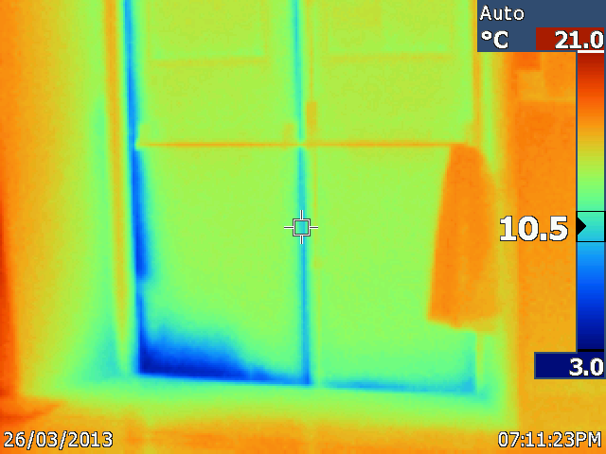
Observation | Comment
Cold surfaces are seen to the base and sides of the fire escape doors | Because the doors have to work in an emergency it is not desirable for them to have too tight a fit.

8. Kitchen – loft hatch
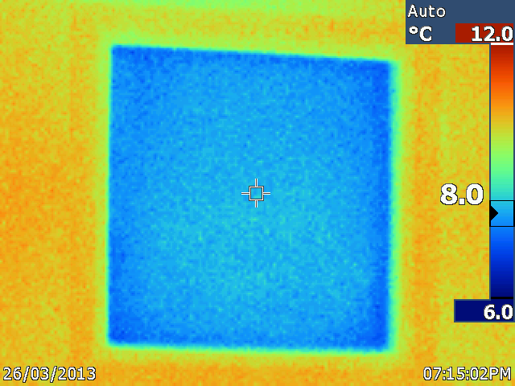
Observation | Comment
The loft hatch is cool | The loft hatch is probably un-insulated.

9. Kitchen – un-insulated pipes

These pipes were noted at floor level in the space between two cupboards in the corner immediately ahead and to the left as one enters the kitchen.

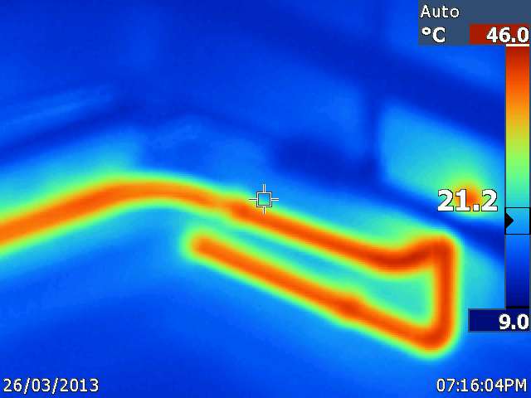
Observation | Comment
Pipes showing a temperature of around 46 degrees | This is probably a hot water pipe rather than a heating pipe) as the kitchen is not heated.

10. Kitchen – wall immediately above the entrance
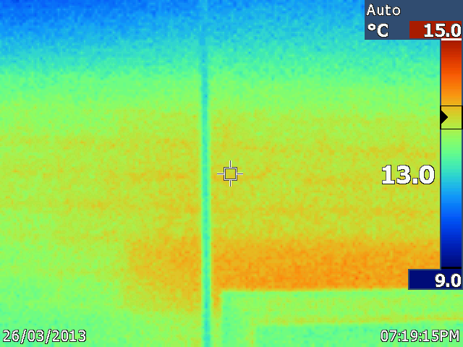
Observation | Comment
A sharp change in temperature is observed. | This picture is interesting as it shows the heat that is transmitted through the heated corridor wall into the kitchen. The cold part corresponds with the corridor ceiling, above which is un-heated loft space.

11. Guides’ store
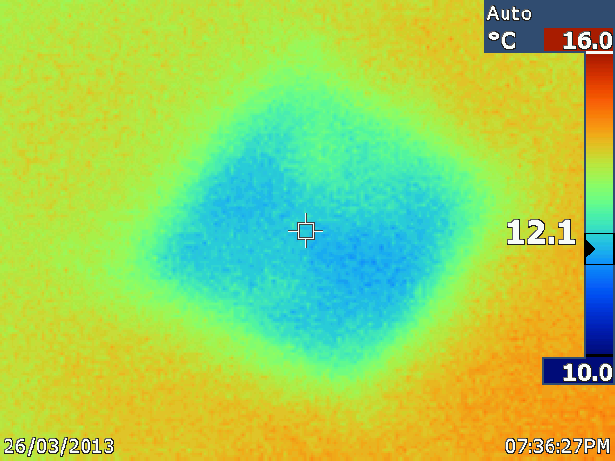
Observation | Comment
Cool anomaly in ceiling above the door. | Potentially missing insulation in the ceiling above the guides’ store. At the least, this image demonstrated that there is some insulation in this location!

12. Skylight in corridor

There are three (?) of these lights in the ceiling of the corridor. They appear to correlate to the valleys between the roof ridges. The glass is single skinned. All showed similar heat patterns.
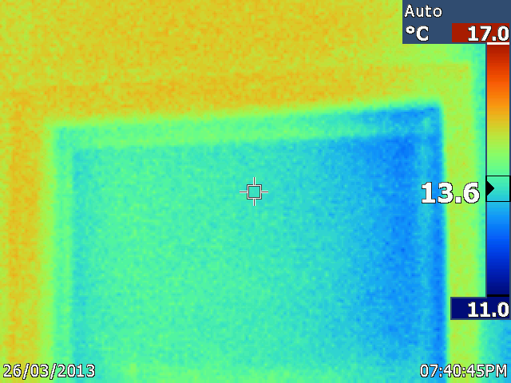
Observation | Comment
The glass and the frame are quite cool | These skylights may be losing heat.

13. Room 2
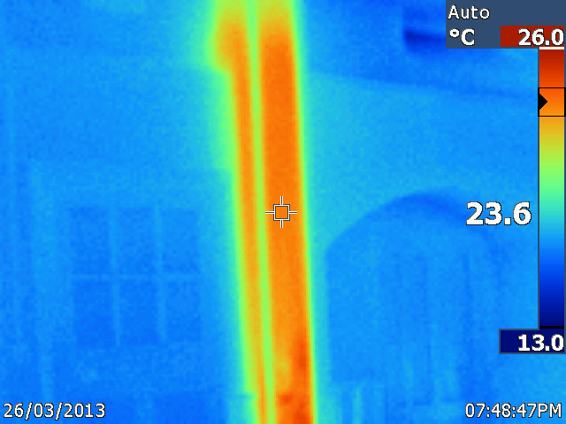
Observation | Comment
A heat anomaly is seen in a boxed off part of the wall between two doors. | This is probably the route of the heating pipes into the room, as heat pipes can be traced leading to the radiators. This heat is not observed on the other side of the wall and hence the pipes are probably in the roof space. In this location the pipes would benefit from effective lagging, which may or may not be present.

14. Boiler Room
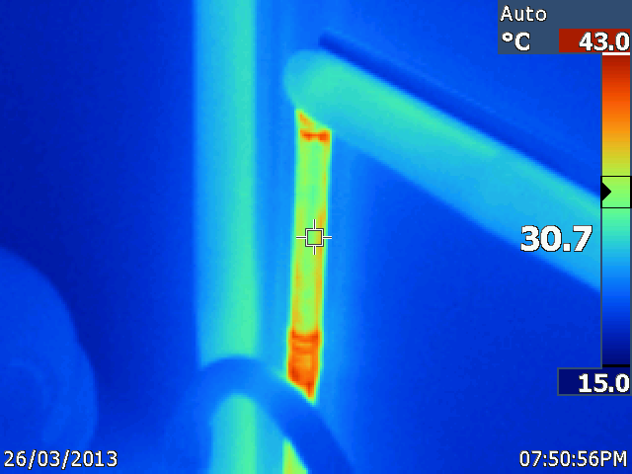
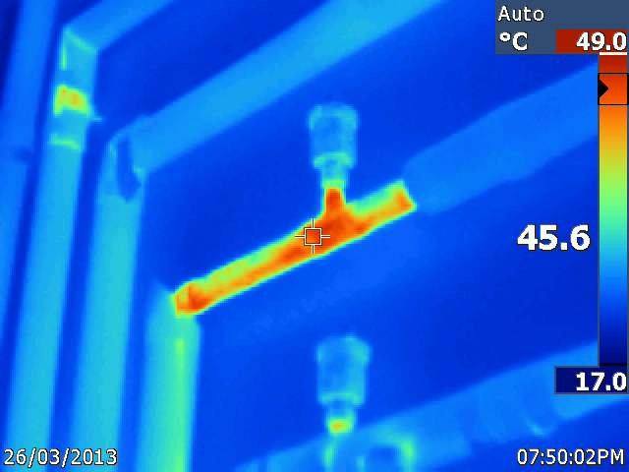
Observation | Comment
Unlagged pipes | The pipe would lose less heat if the insulation was restored.

15. Room 2
This is part of a window which has been truncated when the false ceiling was installed. It is single skinned.
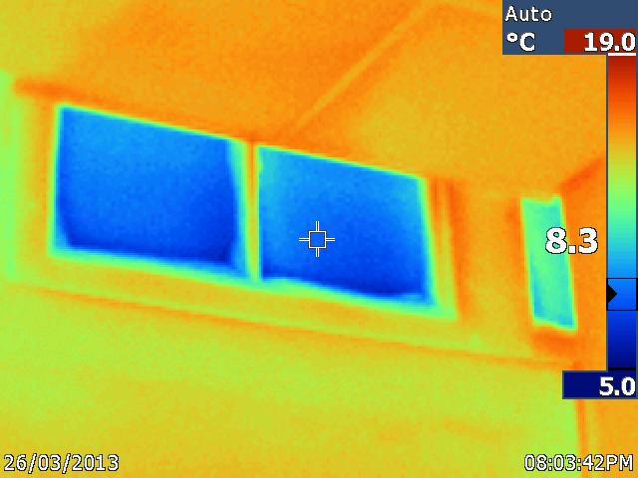
Observation | Comment
The surface is quite cold

16. Fire door
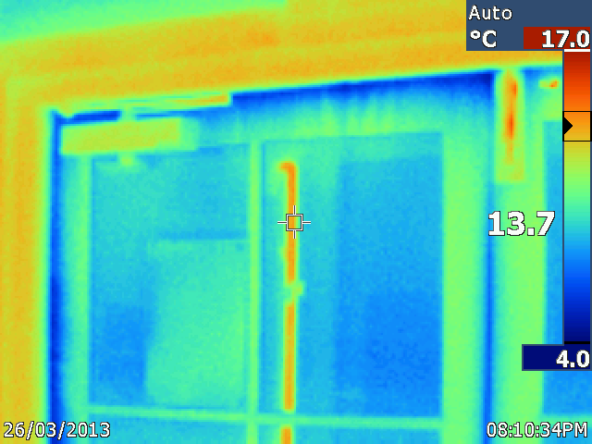
Observation | Comment
Cold anomaly seen around the door | Cool air is accessing the building via this door.

17. Door from corridor into Room 3
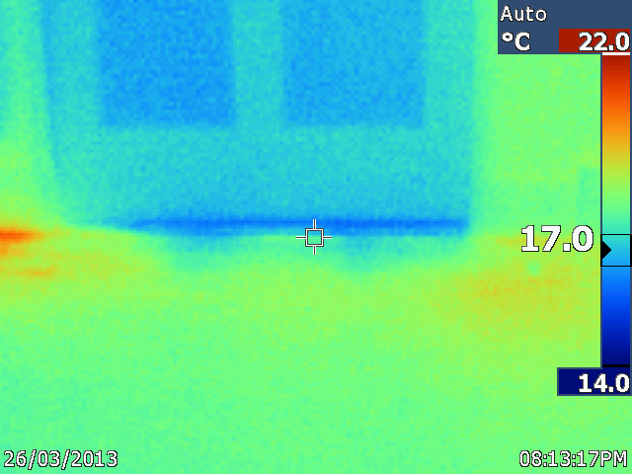
Observation | Comment
Cool surfaces are seen below the door | The Morland Room was quite warm following the recent Zumba session, hence the cooler air form the relatively cold corridor can be seen moving in.

18. Room 3 – West window

This window has been cleverly left with its full height while the ceiling has been lowered.

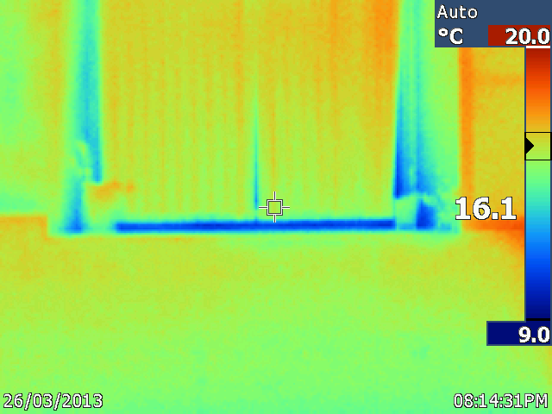
Observation | Comment
Cold patches are observed at the base of the window.  The blinds were seen to be moving in the down-draught of cold air | From the surveyor’s limited observations, this double glazed window seems to be well-fitted and not leaky. However, any window will let out more heat than a wall and because of the height of the window, it may be that the temperature differential sets up a current of air that makes its own draught.

19. Fire door beyond the little kitchen off Room 3
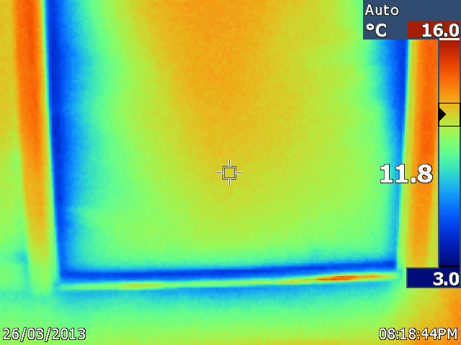
Observation | Comment
Cool patches are observed on the door | This seems to be a poorly insulated door. Compare with image 22 below.

20. Little Kitchen off Room 3

This is the closed door as seen from Room 3

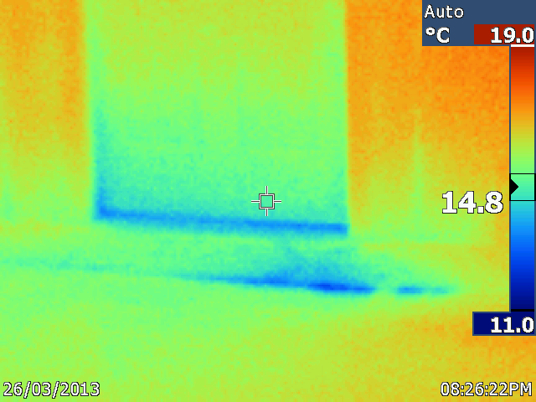
Observation | Comment
Cool patches are seen at the base of the door. | This door connects to a corridor which is not kept as warm as the main room.

21. External – window to south of property
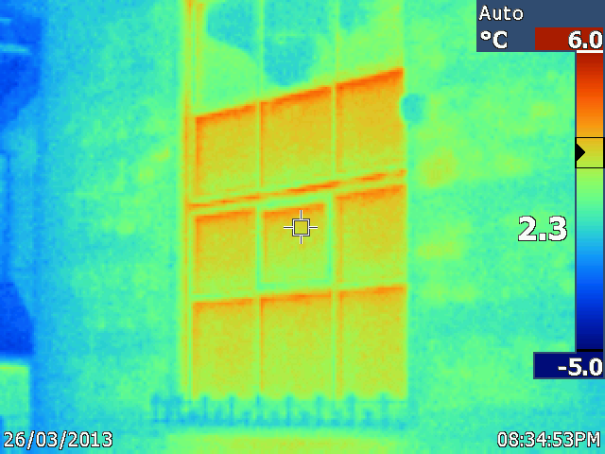
Observation | Comment
Warmer patches are seen on both the window and the walls. | It would seem likely that these traditionally constructed walls are emitting heat differentially depending upon the building material of flint or ashlar blocks.

22. External – window to south of property
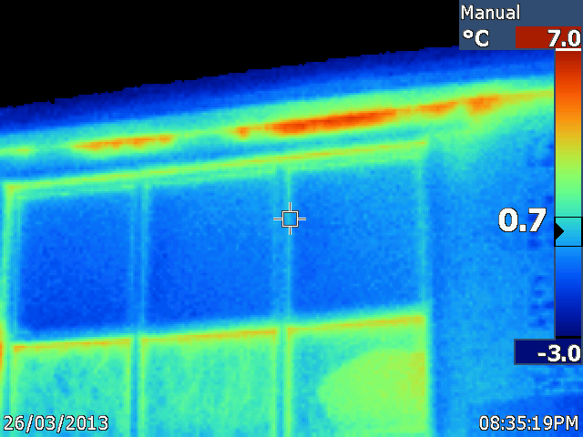
Observation | Comment
Heat anomaly seen below eaves. This may be the window seen from the inside in image 3. | Heat loss is occurring.

22. External – window to east of property
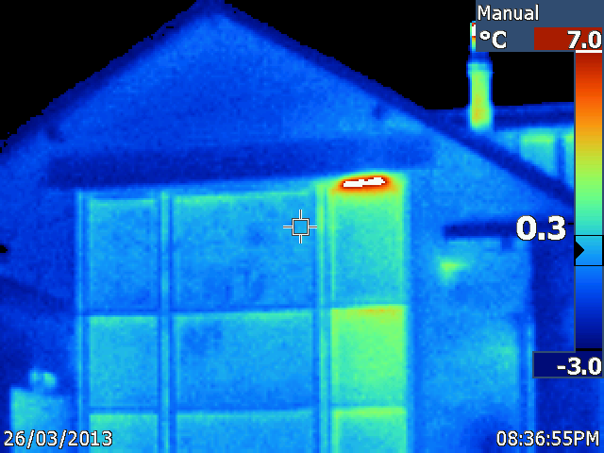
Observation | Comment
Heat anomaly seen above window | Probably the boiler room.

22. Fire door – corridor near little kitchen off Room 3

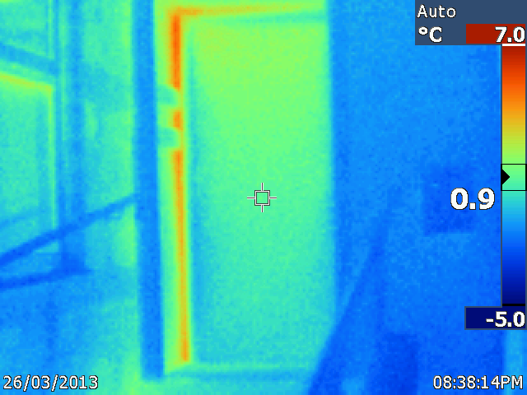
Observation | Comment
Heat anomaly seen | Heat loss is occurring. Compare with the image 19, which shows this door from the inside.

Further observations

Doors and windows with gaps around the edges can be treated using products such as brush pile weather seal to help reduce heat loss.

As part of continuing upgrades it may be worthwhile fitting secondary glazing to single glazed windows. This can be done relatively cheaply using polycarbonate sheeting with magnetic strip attachments.

Loft hatches can merit attention as they are frequently poorly sealed and insulated.

Un-insulated hot water pipes should be insulated wherever they pass through an area that will not benefit from their heating effect.

